Beehives

Some robotic bees are programed to work according to simple rules in order to be as productive as possible. Here are a few rules that these very strange robo-bees follow:
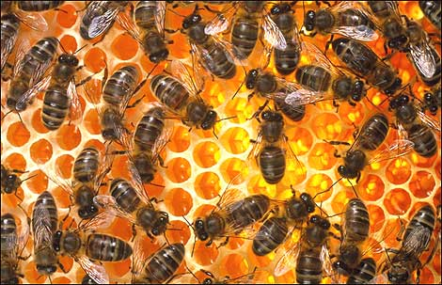

Rule 1: A hive is a collection of robo-bees.
Rule 2: Any two hives must have exactly one robo-bee in common.
Rule 3: Each robo-bee belongs to exactly two hives.

Question: Suppose there are exactly four (4) hives. How many bees are there?

Extension: What if there are 5 hives? 6 hives? 7 hives? N hives?

